**ENSF 614 – Final Project**

**Group 14**

Uzair Anjum

Mark Phillipos

Aaryan Sharma

Kenneth Weech

Table of Contents

System Use-Case Diagram 3

Use-Case Scenarios 4

Class Diagrams 5

Relationship Class Diagram 5

Attribute and Behavior Class Diagrams 6

Controller 6

Model 6

Repository 7

Service 7

Interaction (Sequence) Diagrams 8

User Cancels Ticket – Kenneth Weech 8

Unregistered User Selects Movie – Mark Phillipos 8

Registered User Pays Subscription – Uzair Anjum 9

Registered User Selects Movie – Aaryan Sharma 9

State Transition Diagrams 10

Seat Selection – Kenneth Weech 10

Registered User Login – Mark Phillipos 10

Ticket– Uzair Anjum 11

Payment – Aaryan Sharma 11

System Activity Diagram 12

System Package Diagram 13

System Deployment Diagram 13

# System Use-Case Diagram

# Use-Case Scenarios

|  |  |  |  |
| --- | --- | --- | --- |
| **Scenario** | **Description** | **Filtered Candidate Objects** | **Filtered Candidate Operations** |
| Ordinary user selects movie | This scenario starts when the user selects the movies tab. On that page, there will an input field to search for movie. If the movie is found, the movie is shown on the same page, if not, an error message is displayed. The user selects the movie that was found. | User, Movie | Selects, displayed |
| Registered user selects movie | This scenario starts when the Registered user logs in and selects the movies tab. On that page, there will an input field to search for movie. If the movie is found, the movie is shown on the same page, if not, an error message is displayed. The user selects the movie that was found. | User, Movie | Login, Selects, displayed |
| Ordinary user selects theatre | The user will be able to select the theatre of their choice from the theatres list. | User, Theatre | Selects |
| Registered user selects theatre | A theatre list is shown, and the Registered user selects one of the valid theatres. | Registered User, Theatre | Selects |
| Registered user selects showtime | This scenario starts with a showtime list will be displayed and user selects a showtime. Available seats in the theatre are shown to the user for them to select. | Showtime, User, Seat, Theatre | Selects |
| Registered user selects seats | Registered user selects from the available seats in theatre that are displayed on screen. | Registered User, Theatre, Seat | Selects |
| Registered user checkout | This scenario starts with the User checks out and receives an email receipt of their ticket | User, email, ticket | Check out |
| Ordinary user cancels movie | This scenario starts when the user clicks the link in email receipt to cancel order. If it is greater than or equal to 72 hours before the movie start time, the cancels their purchase. User receives 85% of their original payment as a voucher to their email address. | User, Email, Payment, Voucher | Cancel |
| Registered user cancels movie | This scenario starts when the user clicks the link in email receipt to cancel order. If it is greater than or equal to 72 hours before the movie start time, the cancels their purchase. User receives 100% of their original payment as a voucher to their email address. | User, Email, Voucher, Payment | Cancel |
| Registered user logs in | This scenario starts when the user loads the website and enters login information. | User | Login |
| Registered user pays subscription | This scenario starts after the user logs in and goes to the account tab. The user will see an option to pay annual account fee. User will receive an email receipt of their subscription renewal. | Registered User, Email | Login, Pay |
| Registered user receives movie news | The database engine sends registered user email about pre-purchasing not publicly announce movies. This email will contain a link which will lead the user to select a movie scenario. | Email, Movie, User | Send email, Pre-purchase, Selects |

# Class Diagrams

## Relationship Class Diagram

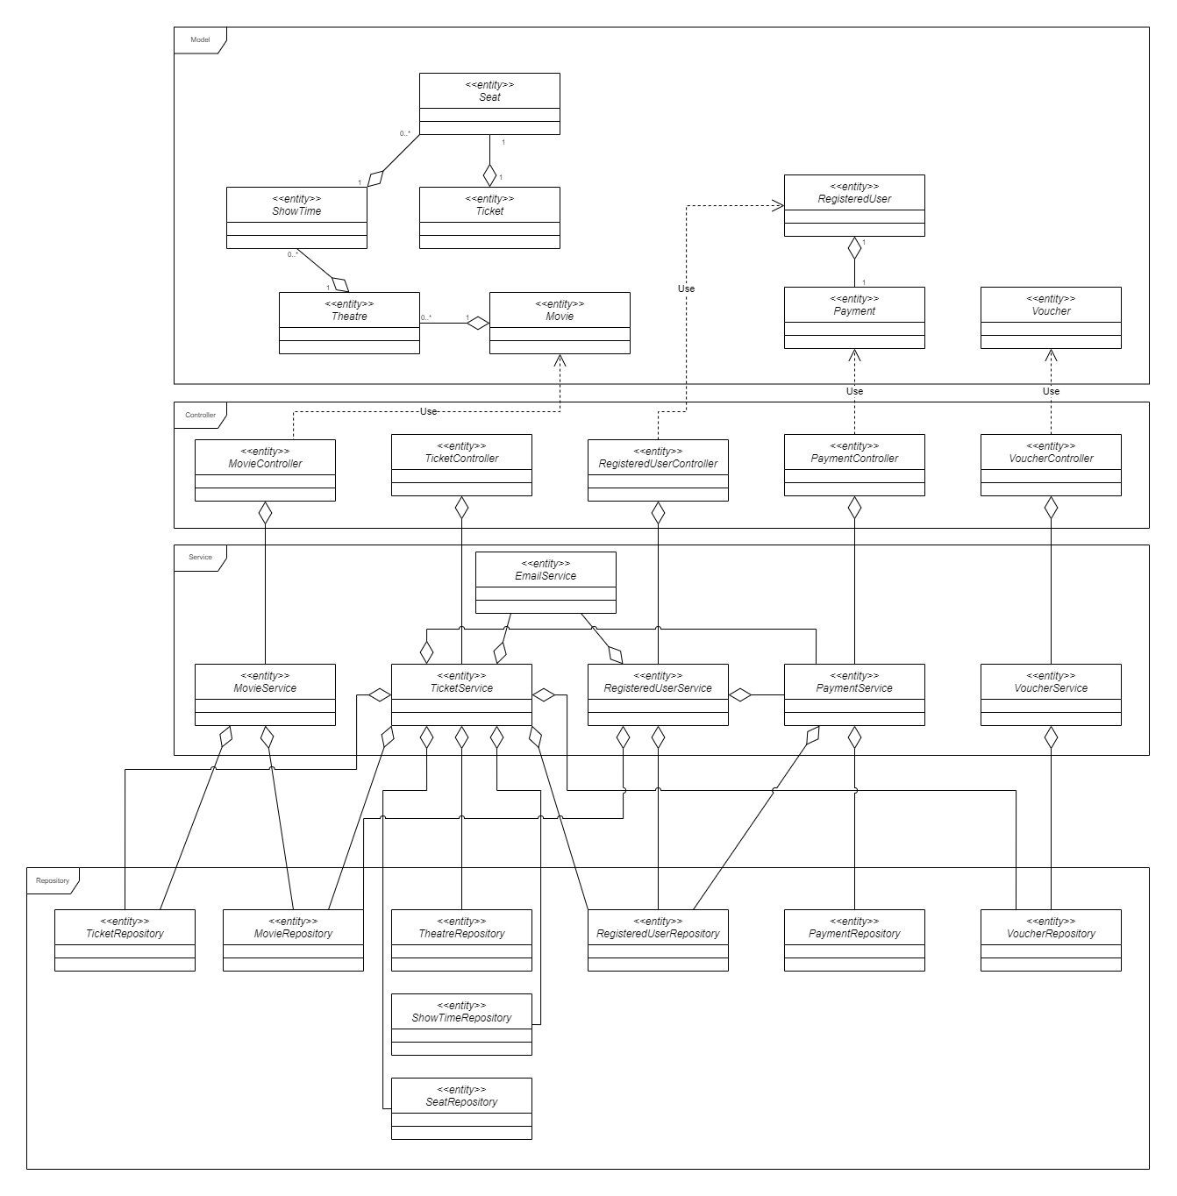

## Attribute and Behavior Class Diagrams

### Controller

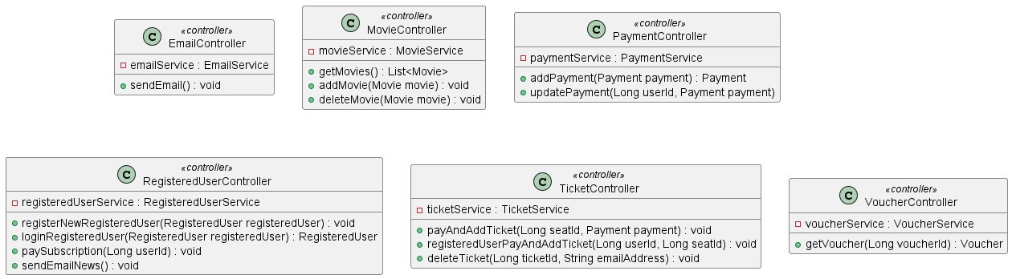

### Model

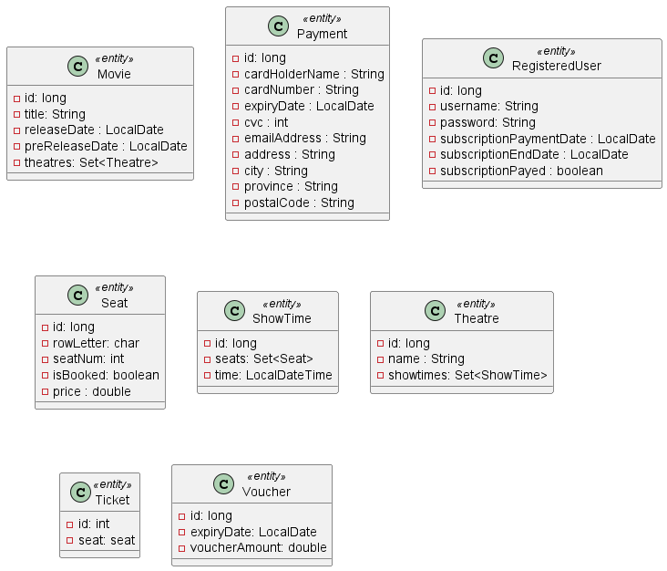

### Repository

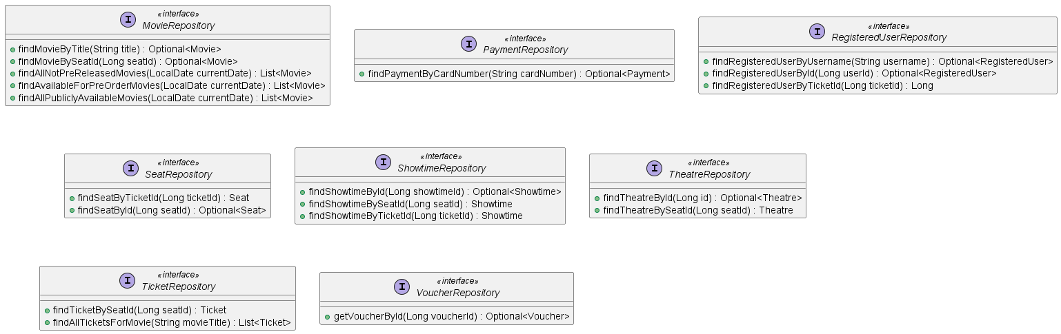

### Service

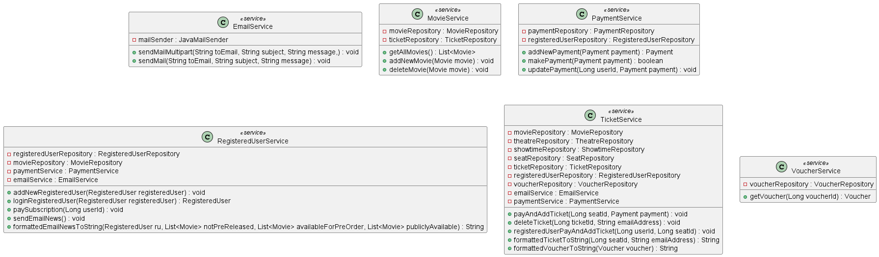

# Interaction (Sequence) Diagrams

## User Cancels Ticket – Kenneth Weech

## Unregistered User Selects Movie – Mark Phillipos

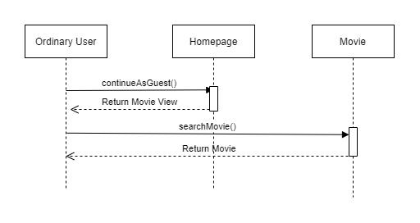

## Registered User Pays Subscription – Uzair Anjum

## Registered User Selects Movie – Aaryan Sharma

# State Transition Diagrams

## Seat Selection – Kenneth Weech

## Registered User Login – Mark Phillipos

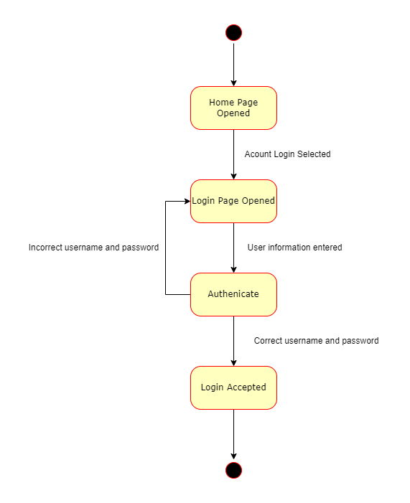

## Ticket– Uzair Anjum

## Payment – Aaryan Sharma

# System Activity Diagram

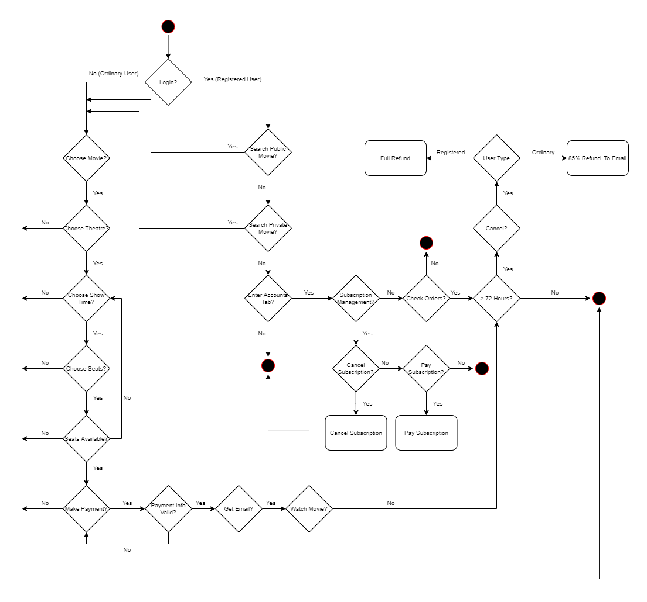

# System Package Diagram

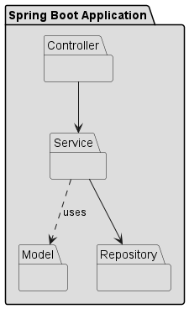

# System Deployment Diagram

